6COSC023W – Project Specifications Design and Prototype

Project Title

Student: Wallyson Alves Da Silva

(w1826139)

Supervisor: Francesco Tusa

This report is submitted in partial fulfillment of the requirements for the

BSc (Hons) Computer Science degree

BEng Software Engineering degree

at the University of Westminster.

School of Computer Science & Engineering

University of Westminster

Date

# Purpose of this document

The purpose of this document is to:

* list the Project's overarching aim and main objectives,
* provide a refined list of project requirements classified as functional/non-functional, as well as basic /essential / luxury (or must have, should have, could have, won't have),
* discuss the method for the elicitation of requirements,
* analyse and model requirements using appropriate diagrams

All word counts in this document are approximate and are not intended to be prescriptive.

# Table of contents

6COSC023W – Project Specifications Design and Prototype 1

Project Title 1

Purpose of this document 2

Table of Contents 3

List of figures 4

1. Aim and Objectives 5

2. Requirements 6

2.1 Stakeholders 6

2.2 Gathering Requirements 8

Remento 8

Life360 9

FamilyAlbum 10

2.3 List of project requirements 11

Functional Requirements 11

Non-functional requirements 12

2.4 Analysis and modelling of requirements 13

2.4.1 Use case Diagram 13

2.4.2 Context Diagram 14

2.4.3 Firebase Structure Diagram 16

2.4.4 Wireframe & Storyboard 18

3. Prototype 21

4. References 22

5. Bibliography 23

Appendix I 23

# List of figures

Figure 1 - Stakeholders Onion Diagram 6

Figure 2 - Remento 8

Figure 3 - Life360 9

Figure 4 - FamilyAlbum 10

Figure 5 - Use case diagram 13

Figure 6 - Context diagram 14

Figure 7- Firebase structure diagram 16

Figure 8 - Wireframe & Storyboard 18

Figure 9 - Login, home page and sidebar menu 19

Figure 10 - Sign up page, join family group 19

Figure 11 - Coloured Mock-up Design 20

# 1. Aim and Objectives

*200 words*

The aim of creating the mobile app HiKiddo is to bridge the distance between parents and children, who are often disconnected due to the rapid pace of modern life. This application seeks to use modern technologies to offer families new and exciting ways to connect through their smartphones. It’s about creating a platform that is engaging and simple for people of all ages, promoting regular and meaningful interactions, like voice messages, photo sharing and challenges to enable creativity and soft life skills even when life gets busy.

Project Objectives:

Develop an Intuitive Interface: Build a welcoming and user-friendly interface suitable for adults and children to encourage accessible and frequent interaction.

Enhance Emotional Bonds: Employ features like voice recordings and personalised messages to deepen the emotional connection between family members. users will have the ability to capture and save stories for their family, which can be replayed at any time.

Create a Gallery for Memories: Set up a feature that enables families to upload and preserve significant moments through photos and videos, contributing to an ongoing compilation of family memories.

Implement a Task and Rewards System: Design a feature where parents can assign tasks — like washing dishes, taking out the trash, or engaging in educational activities. These tasks could not only be designed to keep the household organised but also to promote a hands-on learning experience, teaching children essential life skills. As tasks are completed, family members earn points that can lead to rewards decided by their parents.

By achieving these objectives, the HiKiddo app aims to strengthen family bonds and support the emotional development of children worldwide, tackling the challenges posed by limited parental availability in today's demanding work environment.

# 2. Requirements

Introduce the project stakeholders, the methods for the elicitation of the project requirements, how you model your requirements and relevant diagrams.

## 2.1 Stakeholders

Initially, it's essential to pinpoint who the stakeholders are. Stakeholders are people or groups affected directly or indirectly by this application. Identifying these stakeholders allows us to use specific methods to accurately determine the application needs, ensuring alignment with the user requirements and enhancing its relevance for the target audience.

Figure 1 - Stakeholders Onion Diagram

**Direct Impact**

At the core of the diagram, we have the mobile application representing the project itself.

**Parents and Children:** They are the primary users and are the focus of the app's purpose.

**Developers and Administrator:** These roles are critical to the creation, maintenance, and oversight of the app.

**Supportive stakeholders**

**Investors/Owners:** Could provide financial resources and have a vested interest in the app's success but are not involved in the day-to-day decisions.

**Marketing:** Responsible for promoting the app, essential for market success but not involved in development or usage.

**External Environment**

**Regulatory Bodies:** Ensure that the app complies with legal standards, indirectly influencing its features and operations.

**Third-Party Services Providers:** Offer necessary services that the app depends on, but their influence is more peripheral. Location functionalities and Firebase for database operations serve as examples of such third-party services in this application.

## 2.2 Gathering Requirements

The idea for this project came from noticing that there are not many apps designed for families. A friend who recently became a dad mentioned that having an app to record stories for his child would be nice. This sparked the idea to create an app where families can not only record messages and stories but also save pictures and learn together, especially when parents are busy with work.

It is vital to employ specific techniques to gather requirements more efficiently. To achieve this, research for similar applications was conducted in this project.

Exploring existing similar applications provided a clear view of what is currently available, establishing the foundational requirements. This approach presents an opportunity to identify unique features that can set apart the application under development.

Below are two family-oriented applications, each with features focused on family use: Remento, Life360 and FamilyAlbum.

### **Remento**

Remento is an online platform that helps people save and share important memories with stories by using media like photos, videos, and sounds. It's especially useful now that physical albums and journals are less common. The app includes a unique "speech-to-story" feature, turning voice recordings into text, making it easier to capture stories. While Remento is easy to use, its design, featuring dark tones of green, is more adult-oriented and might not appeal to all ages. Inspired by Remento, including a section for photos and videos is essential for the Hikiddo mobile app. What I find most captivating is the speech-to-story feature, and I'm considering adding a similar concept to the Hikiddo app in the future. However, it's currently not a top priority for development.



Figure 2 - Remento

### **Life360**

Life360's emphasis on family safety through digital and location features is highly relevant to this project. While Life360 offers real-time location tracking and a unique crash detection system, HiKiddo aims to incorporate similar location-based features, ensuring parents can monitor their children’s whereabouts for safety purposes. The user-friendly interface and the tutorial guide of Life360 provide valuable insights into designing an intuitive and easy user interface for HiKiddo. The attractive design elements of Life360, such as colour schemes and animations, are aspects HiKiddo will adopt to ensure continuous user engagement.

Figure 3 - Life360

### **FamilyAlbum**

FamilyAlbum's objective of sharing and organising family moments resonates with HiKiddo’s aim to strengthen family bonds. HiKiddo plans to take inspiration from FamilyAlbum's photo and video sharing feature but will expand it to include interactive elements like voice recording, creating other ways to interact and create personal and memorable moments.

Having thoroughly tested and analysed Life360 and FamilyAlbum, I have acquired crucial insights into their functionality, user interface, and design. These insights will be merged with my innovative ideas and personal perspectives to develop a unique and distinctive application.

Figure 4 - FamilyAlbum

The review of these family-oriented applications provided me with specific inspirations and ideas for the development of the design of the Hikiddo app.

Life360 Inspiration:

User-friendly interface and attractive colour schemes providing insights into designing an intuitive and engaging interface for HiKiddo.

Inspired by Life360, the incorporation of a digital location feature is aimed at enhancing family safety within the HiKiddo app.

FamilyAlbum Inspiration:

Influenced by FamilyAlbum, the feature for sharing and organizing family moments aims to create memorable experiences, allowing the entire family group access to photos and videos.

Remento Inspiration:

Inspired by Remento, a section for voice recordings is planned, alongside a dedicated space for uploading photos and videos.

Remento also introduces the potential for future development with a speech-to-text feature, converting voice recordings into written narratives, to enhance storytelling within the app.

## 2.3 List of project requirements

Here we can find a breakdown of the application's requirements, distinguishing between Functional and Non-Functional aspects. These are further classified into three categories: "Essential," for core functionalities; "Desirable," for features that enhance user experience but are not critical; and "Luxury," for high-end features that offer added value but are not necessary for basic operation.

### **Functional Requirements**

|  |  |
| --- | --- |
| **Requirement** | **Category** |
| Create account | Essential |
| Different users account (users and group host users) | Essential |
| Login | Essential |
| Logout | Essential |
| Change password | Essential |
| Sign up | Essential |
| Join Family group | Essential |
| Create Family group | Essential |
| View Family group | Essential |
| Leave Family group | Essential |
| View/edit account profile | Essential |
| Delete account | Essential |
| Add photo/videos from camera roll to memory board | Essential |
| Add photo/video using the camera memory board | Desirable |
| Record voice | Essential |
| Add date and title to voice recording | Essential |
| Delete voice recording | Essential |
| Host family group user add new challenges | Essential |
| Host family group user add rewards | Essential |
| Users complete the challenges | Essential |
| View user current location | Essential |
| View user last location | Desirable |

### **Non-functional requirements**

|  |  |
| --- | --- |
| Requirement | Category |
| Colourful design, simple layout, user friendly interface | Essential |
| Encryption implementation to increase application security | Essential |
| Notified message when user login | Desirable |
| Notified message when user logout | Desirable |
| Notified message when user creates account | Desirable |
| Password encrypted text in the textbox field | Essential |
| View password typed in the textbox field | Desirable |

## 2.4 Analysis and modelling of requirements

Before progressing to the development stage, it is crucial to craft diagrams that can serve as a roadmap, guaranteeing that the final product aligns with the initial plan. These diagrams act as essential guidelines to be followed throughout the development process.

In this section, it is possible to find the following diagrams: Use Case diagram, Context diagram, database structure, wireframe and mock-up designs.

### **2.4.1 Use case diagram**

Figure 5 - Use case diagram

Using case diagrams aims to provide an understanding of what functionalities it is possible to find in the application, which features are mandatory, being enforced by <<include>> and optional features expressed by <<extend>>.

In this diagram (Figure 5), there are three types of users: unregistered, registered users and registered family group host users.

**Unregistered Users:** As shown in the diagram, this type of user must first sign up for an account before logging into the system to use the application. Unregistered users will be asked to join a family group or to create a new one. By creating a new family group, they become the family group host.

**Registered Users:** As the name entitles, these users are registered into the system, which allows them to login and perform all the features allowed on their domain.

**Registered Family Group Host Users:** These users enjoy all the functionalities available to Registered users, along with additional features exclusive to the family group management.

Once authenticated, the user accesses various engagement features, including the memory board, voice recording, challenges, and viewing family locations. This access enables interaction with specific functionalities on these pages, such as adding new photos/videos, recording new voice messages, or deleting existing voice recordings. These are option features, as seen in the above diagram.

### **2.4.2 Context diagram**

The diagram shown in the image below is a specialised version of a data flow diagram that defines the scope of a system by showing the system boundaries, external entities that interact with the system, and the data flows between these entities and the system.

Figure 6 - Context diagram

Here's an explanation of the various components and processes shown in the context diagram for the Hikiddo mobile app system:

**User:** This represents the individual or external entity interacting with the Hikiddo mobile app system.

**Hikiddo Mobile App - System:** This is the central system of the application, which performs various functions and interacts with external services and the user.

**Sign up/Login:** The user can create a new account or log in to an existing account.

**Authenticate:** The system authenticates the user's identity to provide access to the application.

**Upload photos/videos:** Users can upload photos and videos to the application.

**View family location:** The system allows the user to view the geographic location of family members.

**Record or Delete voice recording:** Users can make voice recordings or delete existing ones.

**Profile Management:** This feature allows users to manage their profile within the app.

**Join the family group:** Users can join existing family groups on the app.

**Location Services**: This is an external service that provides the location data to the app.

**Retrieved location:** The location data retrieved from the Location Services.

**Encrypt Data:** The system encrypts data for security purposes.

**Verify permissions:** The system checks for the necessary permissions before performing specific actions.

**Save data into the database**: Data is saved into the app's database.

**Cloud storage**: This is an external service where the data can be stored securely.

**Users CRUD:** This represents the system's ability to manage user accounts.

**Family Group Management:** The system provides features to manage a family group within the app.

**Add new task to challenges:** Host family group users can add new tasks to the challenges feature.

**Host Family group user:** This implies the system allows the family group host users to have administrative privileges.

This context diagram intends to show a high-level overview of how the user interacts with the system and how the system interacts with external services such as location services and cloud storage.

### **2.4.3 Firebase structure diagram**

Figure 7- Firebase structure diagram

Firebase is a cloud-based platform that utilises a NoSQL database. It's essential to understand the difference between collections, documents, and subcollections and how these elements compare to tables in a conventional relational database.

Collections in Firebase are similar to tables in relational databases, and they contain documents. A collection is used for a group of similar items. In this case, as shown in the figure above, Family_group is collection and each different Family_groups inside of that collection will be characterised as a document.

In Firebase, collections can be linked to tables in traditional relational databases, where they hold documents. A collection groups together similar items. As illustrated in Figure 7, 'Family_group' serves as a collection, and within this collection, each distinct 'Family_group' will be represented as a separate document.

Documents hold the data in key-value pairs and are similar to a row in a table.

Each document is intended to represent an individual instance of your data. For example, in the “user” collection, each document will correspond to a single user.

Subcollections in Firebase are collections nested within a document, designed to represent one-to-many relationships. Within the 'Family_group' entity, there are three distinct subcollections connected by a solid line. This structure will allow users within a family group to access only the data pertinent to their specific group.

“Key representation” in diagram above, is used to represent non-identifying relationships, in this case the dotted lines are used to indicate that the ‘Family_group_id’ is used as a foreign key in the Subcollections tables.

The decision to use Firebase for this project is motivated by the intention to leverage its real-time database feature, utilising the ability to provide immediate, synchronous updates to users. This feature significantly enhances the user experience and ensures consistent data across the application.

It will play a crucial role not only in delivering timely push notifications to users whenever a new photo/video is added to their family group space but also in maintaining up-to-date tracking of family members' locations. This will ensure that the latest, accurate locations are recorded without delays, offering a robust solution for both communication and safety within the family group context.

### **2.4.4 Wireframe & Storyboard**

Creating this wireframe provides a basic outline for the desired mock-up design. By constructing a storyboard, we can further enhance our comprehension of the design's flow and the sequence of user interactions, ensuring a more comprehensive and user-centred approach to the design process. This step will not only facilitate a deeper insight into how users will navigate through the design but also highlight the key actions they can take.

Figure 8 - Wireframe & Storyboard

The process starts with the start page, offering two initial options: login or sign up. Once logged in, users are taken to the homepage, where they can access key functions such as the memory board, voice recording, challenges, and family settings. The bottom navigation menu allows users to switch to their profile or a map showing their relatives' locations. The top navigation bar displays the user's and their family group's name. Clicking on the top “burger” symbol menu triggers a sidebar from the left side of the screen, enabling access to the About and Contact page, plus all the options available on the homepage. See below, Figure 9.

Figure 9 - Login, home page and sidebar menu

If a user doesn't already have an account, they must register one. From the starting page, by selecting 'sign up', they are directed to the registration page. Here, they can create an account and either join an existing family group or establish a new one. On the 'join family group' page, users can search for their family group. If it exists, a dropdown list with similar suggestions and an option to create a new group will appear. If they decide to create a new group, a new sheet with a form will appear to create their family group, making them the host. See below, Figure 10.

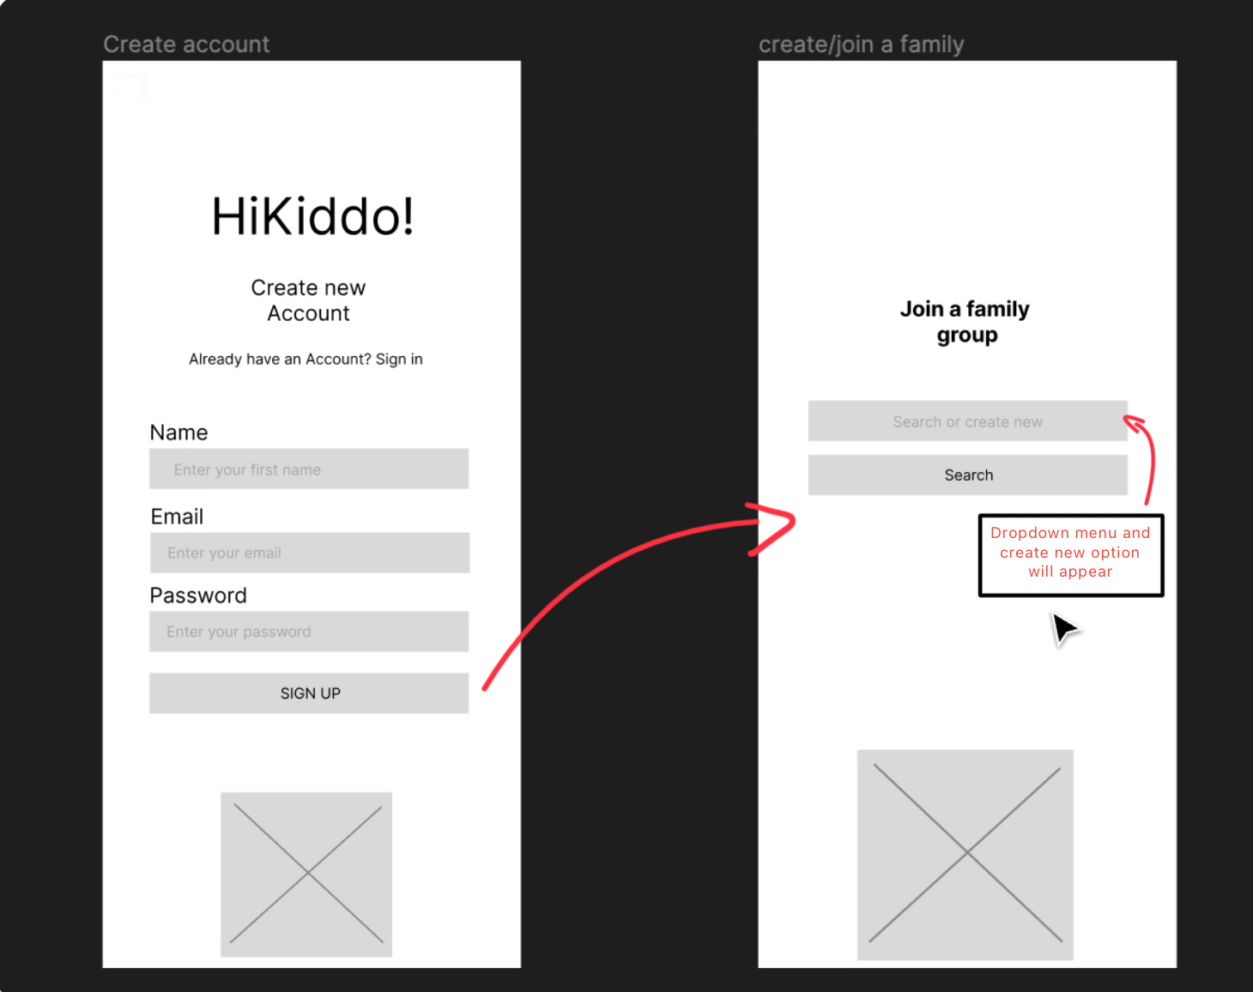

Figure 10 - Sign up page, join family group

**Mock-up design**

Figure 11 - Coloured Mock-up Design

The mock-up design presented above illustrates the user-friendly environment I aim to create, utilising a captivating colour sequence and images relevant to the project's theme. This approach is designed to engage the viewer's attention and seamlessly integrate visual elements that closely align with the project's subject matter.



# 3. Prototype

Link to video demonstrating a prototype that should minimally show a sample user interface and example use of the intended final product. Discuss your engagement with creating the design and intended functionality. Here, you can reference your design documents as well as data preparation and planning.

# 4. References

Include a list of cited in your text items (books, papers, websites, etc.). Use Harvard style for the purpose, or any other preferred standard referencing style.

<https://hackolade.com/blog/the-tao-of-nosql-data-modeling.html>

<https://stackoverflow.com/questions/67531751/how-to-draw-a-nosql-database-document-oriented-with-uml>

<https://firebase.google.com/docs/firestore/data-model>

<https://www.remento.co/#HIW>

<https://www.life360.com/uk/>

<https://family-album.com/en-gb>

<https://docs.flutter.dev/get-started/install>

<https://www.exposit.com/blog/primary-secondary-stakeholders-software-project/>

<https://www.toptal.com/database/the-definitive-guide-to-nosql-databases>

<https://online.visual-paradigm.com/knowledge/system-context-diagram/what-is-system-context-diagram/>

<https://developers.google.com/building-for-kids/designing-engaging-apps>

# 5. Bibliography

Include here a list of general reading items (books, papers, websites, etc.). List the items in alphabetical order, using Harvard style to describe them.

# Appendix I

Provide additional material, if appropriate, in separate appendices.

Use one Appendix to provide a link to an on-line video demo of the prototype

Do not include any printed code as an appendix.